P1

a)



For base case, n =1, if array has one element, it is sorted. This algorithms works because it ensures that the smallest value will be at far left. Largest value will be set to the far right. The first recursive call will sort the first two thirds of the array. The second recursive call will sort last two thirds of the array. And the last recursive call will make sure first two thirds of the array and last two thirds of the array are sorted. Hence, we can prove that the NEW-SORT (A, 1, n) correctly sorts the input array A [1 : n]

b)

T(n) = 3T (2n/3)+ O(1)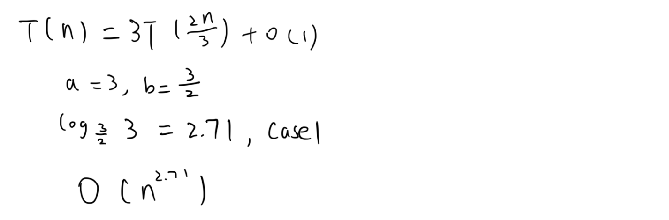

c)

compare with Insertion Sort(O(n2) at worst), Merge Sort(O(nlogn)at worst),Heap Sort(O(nlogn) at worst),, Quick sort(O(n2) at worst), it is a very inefficient sorting algorithm. The student does not deserve a straight A